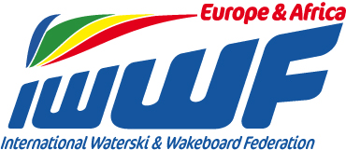 Competitor’s Corner

Info - News Bulletin : 1
European Cup events

Dear Ski friends, racing family

As we all know and see, our European Cup events have been losing “traction”.
We are regretfully heading in the wrong direction…
Today’s format needs tweaking.
We as a council would therefore like to reach out to the ski racing community and find out what they feel needs to be done to get a greater attendance/interest for races at European level.

Ask yourself this :

- Why have I lost interest
- Why am I doing what I am doing, when races are on and I am not attending
- What would be a game changer that motivates me to go
- What is for me an ideal European race scenario
- ….imagine if…..

So put on your thinking caps, consider out of the box ideas and come back to me with anything that you feel can help us go forward and make ski racing great again.

Yours in Water-ski Racing
Chris RYDL

